哈尔滨工业大学计算学部
实验报告

课程名称：数据结构与算法
课程类型：专业核心基础课（必修）
实验项目：线性结构及其应用
实验题目：算术表达式求值（算术计算器）
实验日期：2023/9/20

班级：2203101
学号：2022113573
姓名：张宇杰

设计成绩 | 报告成绩 | 指导老师
 |  | 张岩

一、实验目的
表达式求值是实现程序设计语言的基本问题之一，也是栈的应用的一个典
型例子。一个算术表达式是由操作数（operand）、运算符（operator）和界限符
（delimiter）组成的。假设操作数是正整数，运算符只含加减乘除等四种二元
运算符，界限符有左右括号和表达式起始、结束符“#”，如：#（7+15）*
（23-28/4）#。引入表达式起始、结束符是为了方便。设计一个程序，演示算
术表达式求值的过程。

二、实验要求及实验环境

实验要求：
1. 从文本文件输入任意一个语法正确的（中缀）表达式，显示并保存该表达式。
2. 利用栈结构，把（中缀）表达式转换成后缀表达式，并以适当的方式展示栈
的状态变化过程和所得到的后缀表达式。
3. 利用栈结构，对后缀表达式进行求值，并以适当的方式展示栈的状态变化过
程和最终结果。
4. 选做：将操作数类型扩充到实数、扩充运算符集合，并引入变量操作数，来
完成表达式求值。
5. 选做：设计和实现结合 2 和 3 的“算法优先法”。

实验环境：
Windows 11, g++

三、设计思想（本程序中的用到的所有数据类型的定义，主程序的流程图及各程序模块之间的调用关系、核心算法的主要步骤）
1．逻辑设计
枚举类型TermType
- enum TermType
- {
- NUM = 0,
- OPERATOR
- };
Term类
- class Term
- {
- public:
- TermType type;
- string str;
- Term(TermType type, string str): type(type), str(str) {}
- Term(TermType type, char ch) : type(type), str(1, ch) {}
- };
Term类用于临时存放后缀表达式中的项，TermType记录项类型
在直接计算(direct)的程序中没有使用，仅在间接计算(indirect)中出现

自定义栈 Stack类模版
- // 顺序表实现栈
- template <typename Elem>
- class Stack
- {
- private:
- SeqList<Elem>* arr = nullptr;

- public:
- Stack();
- ~Stack();

- //------------------------------------
- //自身独有的方法
- //------------------------------------

- // 入栈
- void push(const Elem& obj);

- // 出栈
- void pop();

- // 栈顶元素
- const Elem& top() const;

- // 是否为空
- bool empty() const;

- // 栈大小
- int size() const;

- // 遍历元素输出，以separator为分隔符
- void traverse(char separator) const;
- };
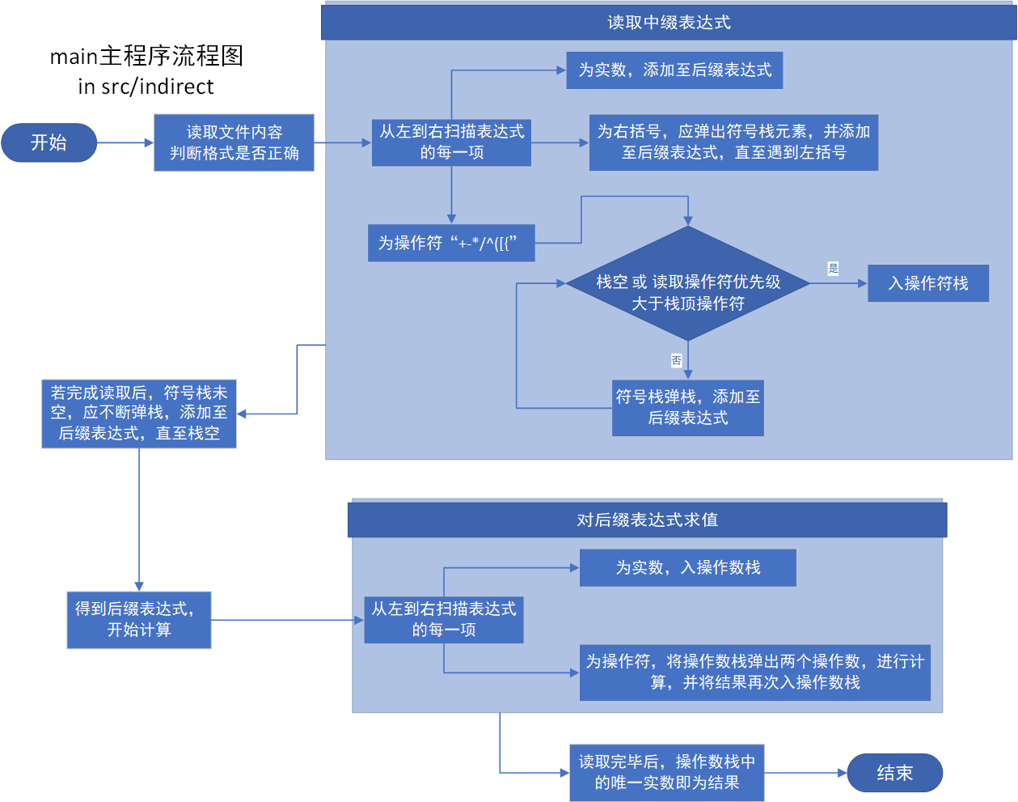
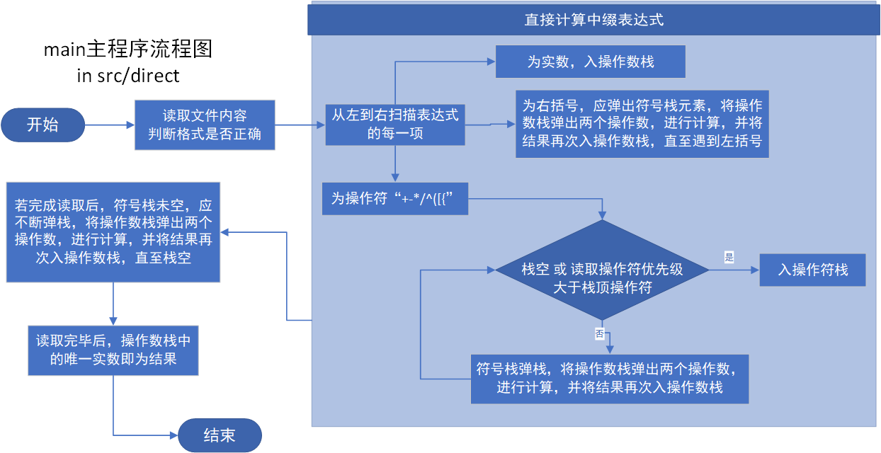
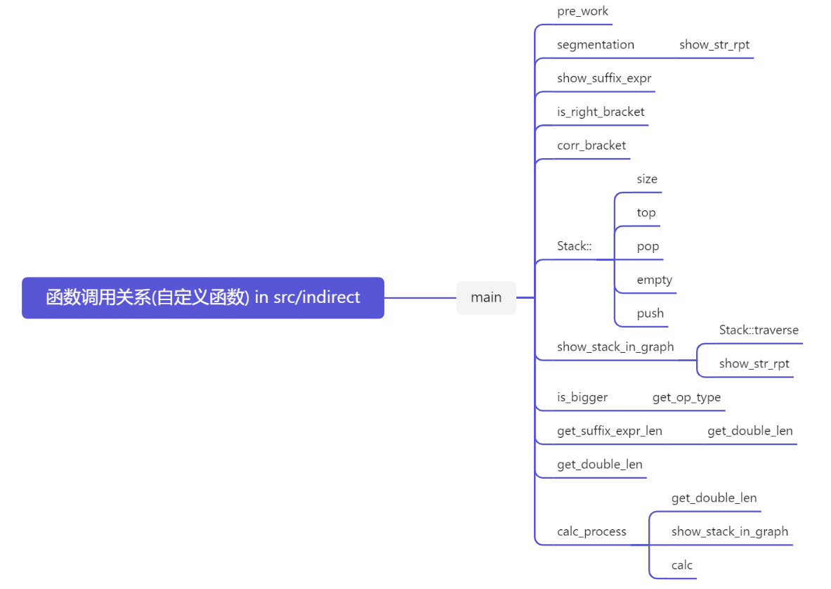
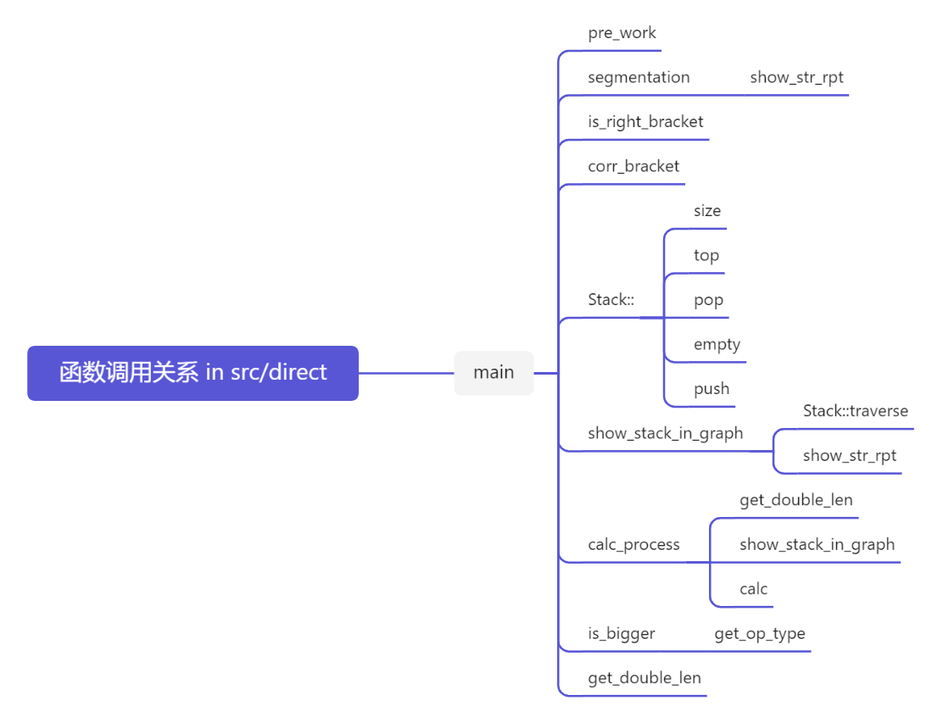
2．物理设计（即存储结构设计）
调用STL模版类vector作为变长数组

线性表及其派生类设计
（对MyList的简单介绍可见./Project/src/header/MyList/README.md）
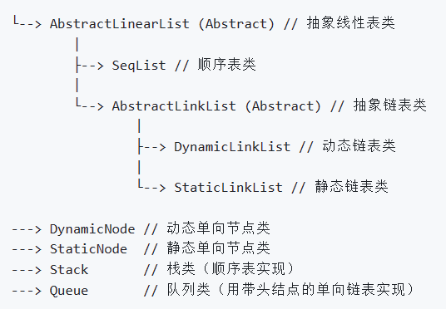
Stack类模板设计如下
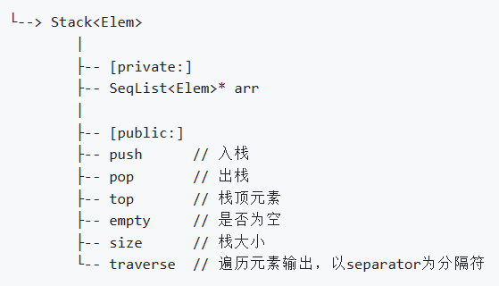
顺序表类模板设计如下
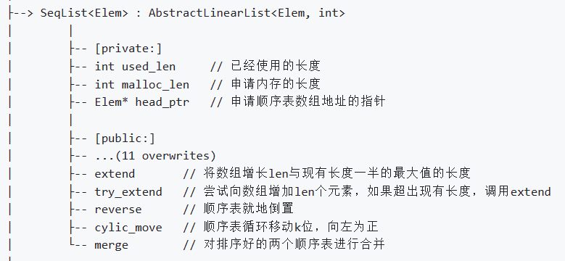
具体内部实现见源代码
四、测试结果（包括测试数据、结果数据及结果的简单分析和结论，可以用截图得形式贴入此报告）
（以下对indirect程序进行测试，direct程序同理）

test-1：简单表达式的计算
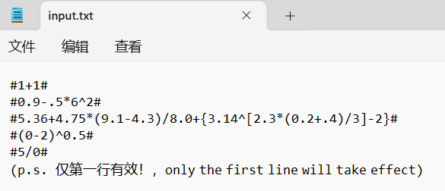
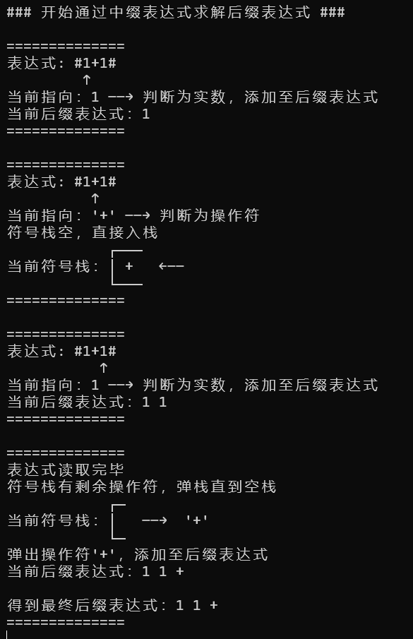
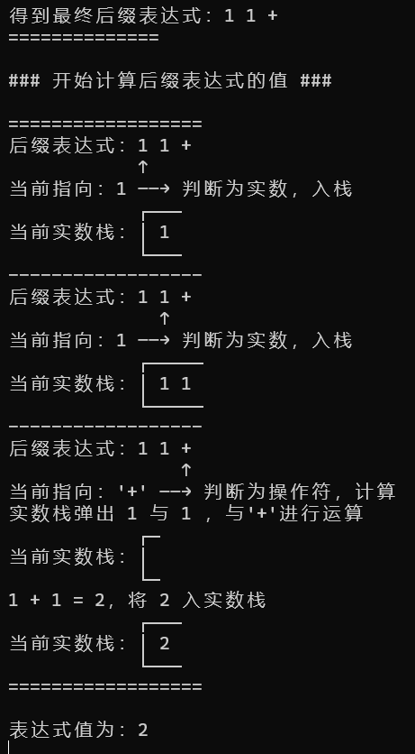
结论：正确执行

test-2：复杂表达式的计算
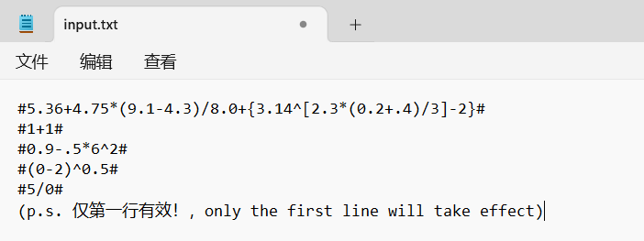
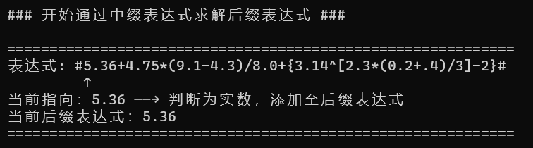
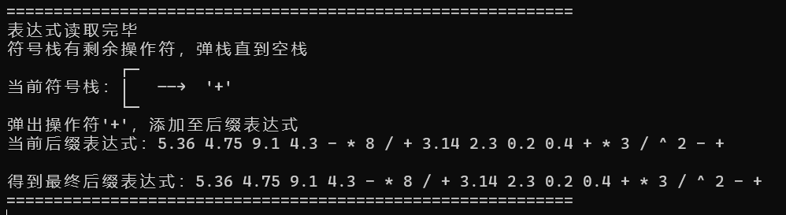
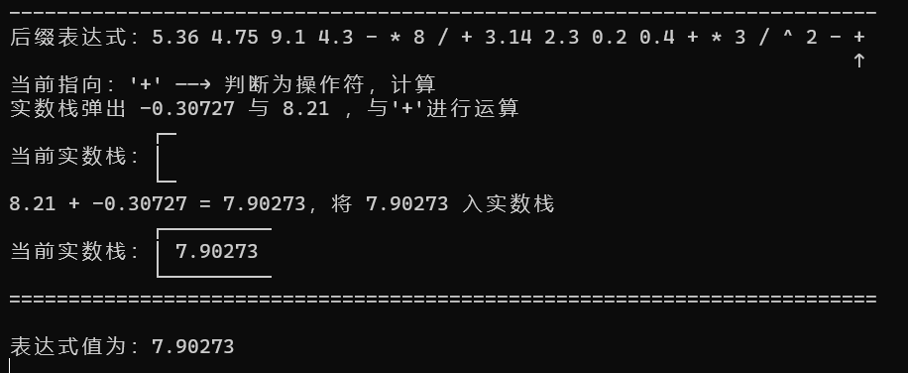
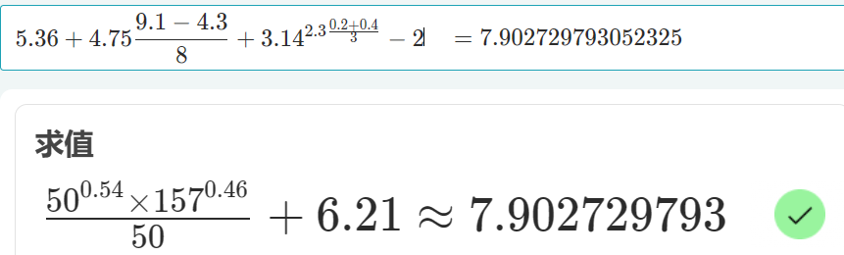
结论：计算正确

test-3：除零错误
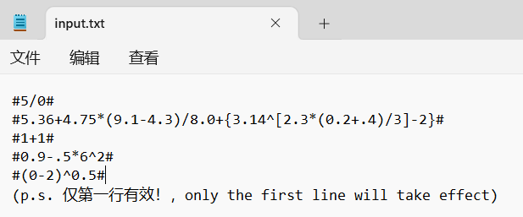
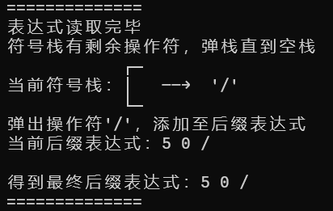
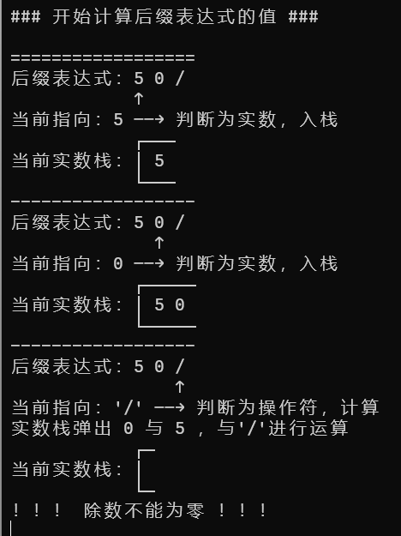
结论：行为符合预期

test-4：求幂错误
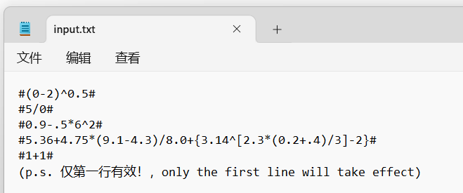
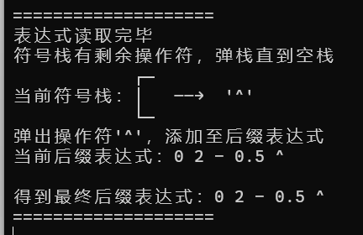
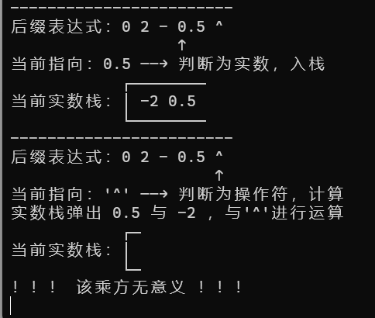
结论：行为符合预期

五、经验体会与不足
体会：熟练掌握了表达式求值的过程，体会到栈这种数据结构的重要性
不足：没有以图形界面展现出求解过程
六、附录：源代码（带注释）

./Project/src/indirect/main.cpp
- using namespace std;

- #include "../header/util.h"

- int priority_table[8][8] = {
- {0, 0, 0, 0, 0, 1, 1, 1},
- {0, 0, 0, 0, 0, 1, 1, 1},
- {1, 1, 0, 0, 0, 1, 1, 1},
- {1, 1, 0, 0, 0, 1, 1, 1},
- {1, 1, 1, 1, 1, 1, 1, 1},
- {1, 1, 1, 1, 1, 1, 1, 1},
- {1, 1, 1, 1, 1, 1, 1, 1},
- {1, 1, 1, 1, 1, 1, 1, 1}
- };

- int main(int argc, const char *argv[])
- {
- ifstream input("input.txt", ios::binary);
- string expr;
- int len;

- // get the whole infix expression, and the length of it
- pre_work(input, expr, len);

- // stack for operators
- Stack<char> st_op;

- // vector for suffix expression
- vector<Term> suffix_expr;

- // discard the character '#'
- input.get();

- // start progress 1 : calc out the suffix expression
- cout << "### 开始通过中缀表达式求解后缀表达式 ###\n" << endl;

- char ch;
- while (ch = input.peek(), ch != '#')
- // peek the initial character of the term
- {
- segmentation('=', len + 9);

- // show the reading expression
- cout << "表达式: " << expr << endl;

- // show the arrow "↑" pointing to the term which is being reading
- cout << string((int)input.tellg() + 8, ' ') << "↑" << endl;

- if (isdigit(ch) || ch == '.')
- // if the term is a double
- // i.e. the term with the beginning character of "0123456789."
- // should be push back into the suffix expr
- {
- double num;
- // read the double
- input >> num;

- // show progress
- cout << "当前指向：" << num << " ——→ 判断为实数，添加至后缀表达式" << endl;

- // push back the term into the suffix expression
- suffix_expr.emplace_back(Term(NUM, to_string(num)));

- // show current suffix expression
- show_suffix_expr("当前后缀表达式：", suffix_expr);
- }
- else if (is_right_bracket(ch))
- // if the term is a right bracket
- // i.e. be of ")]}"
- // the operator stack should pop until meet the corresponding bracket
- // i.e. be of "([{"
- {
- // discard the character
- input.get();

- // show progress
- cout << "当前指向：\'" << ch << "\' ——→ 判断为右括号，应弹出符号栈元素，直到遇到左括号\'" << corr_bracket(ch) << '\'' << endl;

- // show current operator stack
- show_stack_in_graph(st_op, ' ', 0, 0, st_op.size() * 2 + 1, "当前符号栈");
- getch();

- char op;
- while (op = st_op.top(), st_op.pop(), op != corr_bracket(ch))
- // the operator stack should pop until meet the corresponding left bracket
- {
- // show progress
- cout << "符号栈中弹出符号：\'" << op << "\'，添加至后缀表达式" << endl;

- // push back the popped operator into the suffix expr
- suffix_expr.emplace_back(Term(OPERATOR, op));

- // show current suffix expression
- show_suffix_expr("当前后缀表达式：", suffix_expr);

- // show current operator stack
- show_stack_in_graph(st_op, ' ', 2, op, st_op.size() * 2 + 1, "当前符号栈");
- getch();

- segmentation('-', len + 9);
- }
- // show the corresponding left bracket, and the progress
- cout << "符号栈中弹出符号：\'" << op << "\'，结束弹栈" << endl;

- // show current operator stack
- show_stack_in_graph(st_op, ' ', 2, op, st_op.size() * 2 + 1, "当前符号栈");

- // show current suffix expression
- show_suffix_expr("当前后缀表达式：", suffix_expr);
- }
- else
- // if the term is a operator
- // i.e. be of "+-*/^([{"
- // push into the operator stack, obeying the rule "the upper op's priority should be greater than its lower op's"
- {
- // discard the character
- input.get();

- // show progress
- cout << "当前指向：\'" << ch << "\' ——→ 判断为操作符" << endl;
- while (1)
- {
- if (st_op.empty() || is_bigger(ch, st_op.top()))
- // op-stack is empty, or the reading character is "bigger" than the top one
- // push in direct
- {
- // show progress
- if (st_op.empty())
- cout << "符号栈空，直接入栈" << endl;
- else
- cout << "当前操作符\'" << ch << "\'的优先级大于符号栈顶的操作符：\'" << st_op.top() << "\'，将\'" << ch << "\'入栈" << endl;

- st_op.push(ch);

- // show current operator stack
- show_stack_in_graph(st_op, ' ', 1, 0, st_op.size() * 2 + 1, "当前符号栈");

- // over
- break;
- }
- else
- // the reading character is "not bigger" than the top one
- // pop the op-stack until the the reading character is "bigger" than the top one
- {
- // get op-stack top
- char temp = st_op.top();

- // show progress
- cout << "当前操作符\'" << ch << "\'的优先级不大于符号栈顶的操作符：\'" << temp << "\'，符号栈弹栈" << endl;

- // push back the popped operator into the suffix expr
- suffix_expr.emplace_back(Term(OPERATOR, temp));

- // show current suffix expression
- show_suffix_expr("当前后缀表达式：", suffix_expr);

- // op-stack pop
- st_op.pop();

- // show current operator stack
- show_stack_in_graph(st_op, ' ', 2, temp, st_op.size() * 2 + 1, "当前符号栈");
- getch();

- segmentation('-', len + 9);

- // pop the op-stack until the the reading character is "bigger" than the top one
- }
- }
- }
- segmentation('=', len + 9, '\n');
- getch();
- }
- input.close();
- segmentation('=', len + 9);

- // show progress
- cout << "表达式读取完毕" << endl;

- if (!st_op.empty())
- // if there are some operators left in the op-stack
- {
- // show progress
- cout << "符号栈有剩余操作符，弹栈直到空栈" << endl;

- while (!st_op.empty())
- // while there are some operators left in the op-stack
- {
- // get top and pop
- char temp = st_op.top();
- st_op.pop();

- // show current operator stack
- show_stack_in_graph(st_op, ' ', 2, temp, st_op.size() * 2 + 1, "当前符号栈");

- // show progress
- cout << "弹出操作符\'" << temp << "\'，添加至后缀表达式" << endl;

- // push back the popped operator into the suffix expr
- suffix_expr.emplace_back(Term(OPERATOR, temp));

- // show current suffix expression
- show_suffix_expr("当前后缀表达式：", suffix_expr);
- getch();

- if (st_op.size() != 0)
- segmentation('-', len + 9);
- }
- }
- cout << endl;

- // show final suffix expression
- show_suffix_expr("得到最终后缀表达式：", suffix_expr);

- segmentation('=', len + 9);
- getch();

- //==============================================================================

- // start progress 2 : calc the value of the expression
- cout << "\n### 开始计算后缀表达式的值 ###\n" << endl;

- // stack for operation nums
- Stack<double> st_num;

- // calc the title len (just for aesthetics)
- int title_len = get_suffix_expr_len(suffix_expr);

- // show title, 12 is the len of "后缀表达式："
- segmentation('=', title_len + 12);

- int arrow_index = 12;

- // the len of "─" to be illustrated
- int stack_boundary_len = 1;

- for (int i = 0; i < suffix_expr.size(); ++i)
- {
- // show suffix expression
- show_suffix_expr("后缀表达式：", suffix_expr);

- // show arrow pointing to the term being read
- cout << string(arrow_index, ' ') << "↑" << endl;

- Term& now_term = suffix_expr.at(i);
- if (now_term.type == NUM)
- // the term is a double (operand)
- {
- // get the double value
- double temp = stod(now_term.str);

- // show progress
- cout << "当前指向：" << temp << " ——→ 判断为实数，入栈" << endl;

- // push into the operand stack
- st_num.push(temp);

- // increase the stack boundary length, the extra 1 is for the separator ' '
- stack_boundary_len += (get_double_len(temp) + 1);

- // show current operand stack
- show_stack_in_graph(st_num, ' ', 0, 0, stack_boundary_len, "当前实数栈");

- // increase the arrow index, let the arrow point to the next term, the extra 1 is for the separator ' '(space)
- arrow_index += (get_double_len(temp) + 1);
- }
- else
- // the term is a operator
- {
- // show progress
- cout << "当前指向：\'" << now_term.str << "\' ——→ 判断为操作符，计算" << endl;

- calc_process(st_num, stack_boundary_len, now_term.str[0]);

- // increase the arrow index, let the arrow point to the next term
- // for 2, one is for the operator, the other one is for separator ' '(space)
- arrow_index += 2;
- }

- if (i != suffix_expr.size() - 1)
- // if it is not the last term
- // print the segmentation
- segmentation('-', title_len + 12);

- getch();
- }
- segmentation('=', title_len + 12, '\n');

- // show final result
- cout << "表达式值为：" << st_num.top() << endl;
- getch();

- return 0;
- }

./Project/src/direct/main.cpp
- using namespace std;

- #include "../header/util.h"

- int priority_table[8][8] = {
- {0, 0, 0, 0, 0, 1, 1, 1},
- {0, 0, 0, 0, 0, 1, 1, 1},
- {1, 1, 0, 0, 0, 1, 1, 1},
- {1, 1, 0, 0, 0, 1, 1, 1},
- {1, 1, 1, 1, 1, 1, 1, 1},
- {1, 1, 1, 1, 1, 1, 1, 1},
- {1, 1, 1, 1, 1, 1, 1, 1},
- {1, 1, 1, 1, 1, 1, 1, 1}
- };

- int main(int argc, const char *argv[])
- {
- ifstream input("input.txt", ios::binary);
- string expr;
- int len;

- // get the whole infix expression, and the length of it
- pre_work(input, expr, len);

- // stack for operators
- Stack<char> st_op;

- // stack for nums
- Stack<double> st_num;

- // discard the character '#'
- input.get();

- // start progress : calc the value of the infix expression
- cout << "### 开始计算中缀表达式的值 ###\n" << endl;

- char ch;

- // the len of "─" to be illustrated
- int stack_boundary_len = 1;

- while (ch = input.peek(), ch != '#')
- // peek the initial character of the term
- {
- segmentation('=', len + 9);

- // show the reading expression
- cout << "表达式: " << expr << endl;

- // show the arrow "↑" pointing to the term which is being reading
- cout << string((int)input.tellg() + 8, ' ') << "↑" << endl;

- if (isdigit(ch) || ch == '.')
- // if the term is a double
- // i.e. the term with the beginning charactor of "0123456789."
- // should be push into the op-num-stack
- {
- double num;
- // read the double
- input >> num;

- // show progress
- cout << "当前指向：" << num << " ——→ 判断为实数，入实数栈" << endl;

- // push the num into the op-num-stack
- st_num.push(num);

- // increase the op-num-stack boundary length, the extra 1 is for the separator ' '
- stack_boundary_len += (get_double_len(num) + 1);

- // show current op-num-stack
- show_stack_in_graph(st_num, ' ', 0, 0, stack_boundary_len, "当前实数栈");
- }
- else if (is_right_bracket(ch))
- // if the term is a right bracket
- // i.e. be of ")]}"
- // the operator stack should pop until meet the corresponding bracket
- // i.e. be of "([{"
- {
- // discard the character
- input.get();

- // show progress
- cout << "当前指向：\'" << ch << "\' ——→ 判断为右括号，应弹出符号栈元素，直到遇到左括号\'" << corr_bracket(ch) << '\'' << endl;

- // show current operator stack
- show_stack_in_graph(st_op, ' ', 0, 0, st_op.size() * 2 + 1, "当前符号栈");
- getch();

- segmentation('-', len + 9);

- char op;
- while (op = st_op.top(), st_op.pop(), op != corr_bracket(ch))
- // the operator stack should pop until meet the corresponding left bracket
- {
- // show progress
- cout << "符号栈中弹出符号：\'" << op << "\'，进行计算" << endl;

- // show current op-stack
- show_stack_in_graph(st_op, ' ', 2, op, st_op.size() * 2 + 1, "当前符号栈");

- calc_process(st_num, stack_boundary_len, op);
- getch();

- segmentation('-', len + 9);
- }
- // show the corresponding left bracket, and the progress
- cout << "符号栈中弹出符号：\'" << op << "\'，结束弹栈" << endl;

- // show current operator stack
- show_stack_in_graph(st_op, ' ', 2, op, st_op.size() * 2 + 1, "当前符号栈");
- // show current op-num-stack
- show_stack_in_graph(st_num, ' ', 0, 0, stack_boundary_len, "当前实数栈");
- }
- else
- // if the term is a operator
- // i.e. be of "+-*/^([{"
- // push into the operator stack, obeying the rule "the upper op's priority should be greater than its lower op's"
- {
- // discard the character
- input.get();

- // show progress
- cout << "当前指向：\'" << ch << "\' ——→ 判断为操作符" << endl;
- while (1)
- {
- if (st_op.empty() || is_bigger(ch, st_op.top()))
- // op-stack is empty, or the reading character is "bigger" than the top one
- // push in direct
- {
- // show progress
- if (st_op.empty())
- cout << "符号栈空，直接入栈" << endl;
- else
- cout << "当前操作符\'" << ch << "\'的优先级大于符号栈顶的操作符：\'" << st_op.top() << "\'，将\'" << ch << "\'入栈" << endl;

- st_op.push(ch);

- // show current operator stack
- show_stack_in_graph(st_op, ' ', 1, 0, st_op.size() * 2 + 1, "当前符号栈");

- // over
- break;
- }
- else
- // the reading character is "not bigger" than the top one
- // pop the op-stack until the the reading character is "bigger" than the top one
- {
- // get op-stack top
- char temp = st_op.top();

- // show progress
- cout << "当前操作符\'" << ch << "\'的优先级不大于符号栈顶的操作符：\'" << temp << "\'，符号栈弹栈，进行计算" << endl;

- // op-stack pop
- st_op.pop();

- // show current operator stack
- show_stack_in_graph(st_op, ' ', 2, temp, st_op.size() * 2 + 1, "当前符号栈");

- calc_process(st_num, stack_boundary_len, temp);
- getch();

- segmentation('-', len + 9);
- // pop the op-stack until the the reading character is "bigger" than the top one
- }
- }
- }
- segmentation('=', len + 9, '\n');
- getch();
- }
- input.close();

- segmentation('=', len + 9);

- if (!st_op.empty())
- // if there are some operators left in the op-stack
- {
- // show progress
- cout << "符号栈有剩余操作符，弹栈直到空栈" << endl;

- while (!st_op.empty())
- // while there are some operators left in the op-stack
- {
- // get top and pop
- char temp = st_op.top();
- st_op.pop();

- // show progress
- cout << "弹出操作符\'" << temp << "\'，进行计算" << endl;

- // show current operator stack
- show_stack_in_graph(st_op, ' ', 2, temp, st_op.size() * 2 + 1, "当前符号栈");

- calc_process(st_num, stack_boundary_len, temp);
- getch();

- // segmentation
- if (st_op.size() != 0)
- segmentation('-', len + 9);
- }
- }
- segmentation('=', len + 9);

- // show result
- cout << "\n表达式读取完毕，结果为" << st_num.top() << endl;
- getch();

- return 0;
- }

./Project/src/header/util.h
- #ifndef _UTIL_H_INCLUDED_
- #define _UTIL_H_INCLUDED_

- #include <iostream>
- #include "../header/MyList/Stack.hpp"
- #include <vector>
- #include <string>
- #include <fstream>
- #include <cmath>
- #include <conio.h>

- extern int priority_table[8][8];

- enum TermType
- {
- NUM = 0,
- OPERATOR
- };

- class Term
- {
- public:
- TermType type;
- std::string str;
- Term(TermType type, std::string str): type(type), str(str) {}
- Term(TermType type, char ch) : type(type), str(1, ch) {}
- };

- void pre_work(std::ifstream& input, std::string& expr, int& len);

- void show_suffix_expr(std::string memo, std::vector<Term> &v);
- template <typename T>
- void show_stack_in_graph(Stack<T> &st, char separator, int type, char elem, int boundary_len, const std::string& memo);

- void show_str_rpt(std::string str, int times);
- void segmentation(std::string rpt_str, int rpt_cnt, char suffix = '\0');
- void segmentation(char rpt_char, int rpt_cnt, char suffix = '\0');

- int is_bigger(char op_1, char op_2);
- int get_op_type(char op);
- int is_right_bracket(char bracket);
- char corr_bracket(char right_bracket);
- double calc(double a, double b, const std::string& oper);
- int get_double_len(double num);
- int get_suffix_expr_len(std::vector<Term>& suffix_expr);

- void calc_process(Stack<double>& st_num, int& stack_boundary_len, char op);

- // the memo should be 6 Chinese charactor for formating
- template <typename T>
- void show_stack_in_graph(Stack<T> &st, char separator, int type, char elem, int boundary_len, const std::string& memo)
- {
- std::cout << " ┌"; show_str_rpt("─", boundary_len), std::cout << std::endl;
- std::cout << memo << "：│ "; st.traverse(' ');

- switch (type)
- {
- case 0:
- std::cout << std::endl;
- break;
- case 1:
- std::cout << " ←——" << std::endl;
- break;
- case 2:
- std::cout << " ——→ \'" << elem << "\'" << std::endl;
- break;
- }
- std::cout << " └"; show_str_rpt("─", boundary_len), std::cout << std::endl;
- }

- inline void show_str_rpt(std::string str, int times)
- {
- for (int i = 0; i < times; i++)
- std::cout << str;
- }

- inline void segmentation(std::string rpt_str, int rpt_cnt, char suffix)
- {
- show_str_rpt(rpt_str, rpt_cnt);
- std::cout << suffix << std::endl;
- }

- inline void segmentation(char rpt_char, int rpt_cnt, char suffix)
- {
- std::cout << std::string(rpt_cnt, rpt_char) << suffix << std::endl;
- }

- inline int is_bigger(char op_1, char op_2)
- {
- int i = get_op_type(op_1), j = get_op_type(op_2);
- return priority_table[i][j];
- }

- inline int get_op_type(char op)
- {
- std::string str = "+-*/^([{";
- return str.find(op);
- }

- inline int is_right_bracket(char bracket)
- {
- return bracket == ')' || bracket == ']' || bracket == '}';
- }

- inline char corr_bracket(char right_bracket)
- {
- switch (right_bracket)
- {
- case ')':
- return '(';
- case ']':
- return '[';
- case '}':
- return '{';
- default:
- return '\0';
- }
- }

- #endif

./Project/src/header/util.cpp
- #include "util.h"

- void pre_work(std::ifstream& input, std::string& expr, int& len)
- {
- // set terminal to code UTF-8
- system("chcp 65001");

- system("cls");

- // check the validity of the file
- if (input.peek() != '#')
- {
- std::cout << "Input file format error!" << std::endl;
- getch();
- exit(-1);
- }

- // read whole expression, for show purpose
- input >> expr;
- len = expr.length();

- // set the file reading pointer to the beginning of the file
- input.seekg(0);
- }

- // print terms in suffix_expr
- void show_suffix_expr(std::string memo, std::vector<Term> &v)
- {
- std::cout << memo;
- for (auto term: v)
- {
- if (term.type == 0)
- std::cout << stod(term.str) << ' ';
- else
- std::cout << term.str << ' ';
- }
- std::cout << std::endl;
- }

- double calc(double a, double b, const std::string& oper)
- {
- if (oper == "+")
- return a + b;
- else if (oper == "-")
- return a - b;
- else if (oper == "*")
- return a * b;
- else if (oper == "/")
- {
- if (std::isinf(a / b))
- throw "！！！ 除数不能为零 ！！！";
- else
- return a / b;
- }
- else if (oper == "^")
- {
- if (!std::isnormal(pow(a, b)))
- throw "！！！ 该乘方无意义 ！！！";
- else
- return pow(a, b);
- }
- else
- return 0;
- }

- int get_double_len(double num)
- {
- num = (int)(num * 100000) / 100000.0;

- int len = 0;

- if (num < 0)
- {
- ++len;
- num = -num;
- }
- int integer = round(num);

- do
- {
- ++len;
- integer /= 10;
- }
- while (integer > 0);

- double decimals = num - round(num);
- decimals = fabs(decimals);
- if (decimals > 1e-6)
- {
- ++len;
- do
- {
- ++len;
- decimals *= 10;
- decimals -= round(decimals);
- decimals = fabs(decimals);
- }
- while (decimals > 1e-4);
- }

- return len;
- }

- int get_suffix_expr_len(std::vector<Term>& suffix_expr)
- {
- int len = 0;
- for (int i = 0; i < suffix_expr.size(); i++)
- {
- Term &temp = suffix_expr.at(i);
- if (temp.type == NUM)
- len += get_double_len(stod(temp.str));
- else // temp.type == OPERATOR
- len += 1;
- }
- len += suffix_expr.size();
- return len;
- }

- void calc_process(Stack<double>& st_num, int& stack_boundary_len, char op)
- {
- // get the two op-num out, decrease the stack boundary length, the extra 1 is for the separator ' '
- double num2 = st_num.top();
- st_num.pop();
- stack_boundary_len -= (get_double_len(num2) + 1);
- double num1 = st_num.top();
- st_num.pop();
- stack_boundary_len -= (get_double_len(num1) + 1);

- // show progress
- std::cout << "实数栈弹出 " << num2 << " 与 " << num1 << " ，与\'" << op << "\'进行运算" << std::endl;

- // show current operand stack
- show_stack_in_graph(st_num, ' ', 0, 0, stack_boundary_len, "当前实数栈");

- // calc the result
- double res;
- try
- {
- res = calc(num1, num2, std::string(1, op));
- }
- catch (const char* str)
- // math error
- {
- std::cout << str << std::endl;
- getch();
- exit(-1);
- }

- // show progress
- std::cout << num1 << ' ' << op << ' ' << num2 << " = " << res << "，将 " << res << " 入实数栈" << std::endl;

- // push the result into the operand stack, increase the stack boundary length
- st_num.push(res);
- stack_boundary_len += (get_double_len(res) + 1);

- // show current operand stack
- show_stack_in_graph(st_num, ' ', 0, 0, stack_boundary_len, "当前实数栈");
- }

./Project/src/header/MyList/Stack.hpp
- #ifndef STACK_HPP_INCLUDED
- #define STACK_HPP_INCLUDED

- #include "SeqList.hpp"

- // 顺序表实现栈
- template <typename Elem>
- class Stack
- {
- private:
- SeqList<Elem>* arr = nullptr;

- public:
- Stack();
- ~Stack();

- //------------------------------------
- //自身独有的方法
- //------------------------------------

- // 入栈
- void push(const Elem& obj);

- // 出栈
- void pop();

- // 栈顶元素
- const Elem& top() const;

- // 是否为空
- bool empty() const;

- // 栈大小
- int size() const;

- // 遍历元素输出，以separator为分隔符
- void traverse(char separator) const;
- };

- #include "Stack.cpp"

- #endif

./Project/src/header/MyList/Stack.cpp
- #include "Stack.hpp"

- // 构造函数
- template <typename Elem>
- Stack<Elem>::Stack()
- {
- arr = new SeqList<Elem>;
- }

- // 析构函数
- template <typename Elem>
- Stack<Elem>::~Stack()
- {
- if (arr)
- delete arr;
- }

- // 入栈
- template <typename Elem>
- void Stack<Elem>::push(const Elem& obj)
- {
- arr->push_back(obj);
- }

- // 出栈
- template <typename Elem>
- void Stack<Elem>::pop()
- {
- if (! arr->empty())
- arr->remove(arr->prior(arr->end()));
- }

- // 栈顶元素
- template <typename Elem>
- const Elem& Stack<Elem>::top() const
- {
- // 空栈查看栈顶是未定义行为
- return arr->at(arr->prior(arr->end()));
- }

- // 是否为空
- template <typename Elem>
- bool Stack<Elem>::empty() const
- {
- return arr->empty();
- }

- // 栈大小
- template <typename Elem>
- int Stack<Elem>::size() const
- {
- return arr->length();
- }

- // 遍历元素输出，以separator为分隔符
- template <typename Elem>
- void Stack<Elem>::traverse(char separator) const
- {
- arr->traverse(separator);
- }

